Name: __Spencer Sliffe_

Discussion Section: _________FRIDAY 1:00PM____________

LING/ANTH 106 Discussion Week 2:

Nicaraguan Sign Language Worksheet

**______________________________________________________________________________**

**Section 1: Review and experimental method**

* 1. Why did Senghas and Coppola separate the participants by their **date of exposure (cohort)** to Nicaraguan Sign Language?

They separated cohort 1 (pre 1983) and cohort 2 (post 1983) of the Nicaraguan Sign language in order to distinguish the development periods of the language.

* 1. Why did Senghas and Coppola separate the participants by their **age of exposure (age group)** to Nicaraguan Sign Language?

They were interested in who is driving the language. The younger groups were the ones that were using NSL more often.

* 1. How did the researchers elicit spatial modulations from the subjects?

Participants watched a 2-minute cartoon. After watching the cartoon, they recounted the story to a deaf peer using NSL. All instances of spatial modulation were coded and counted.

# Section 2: Results

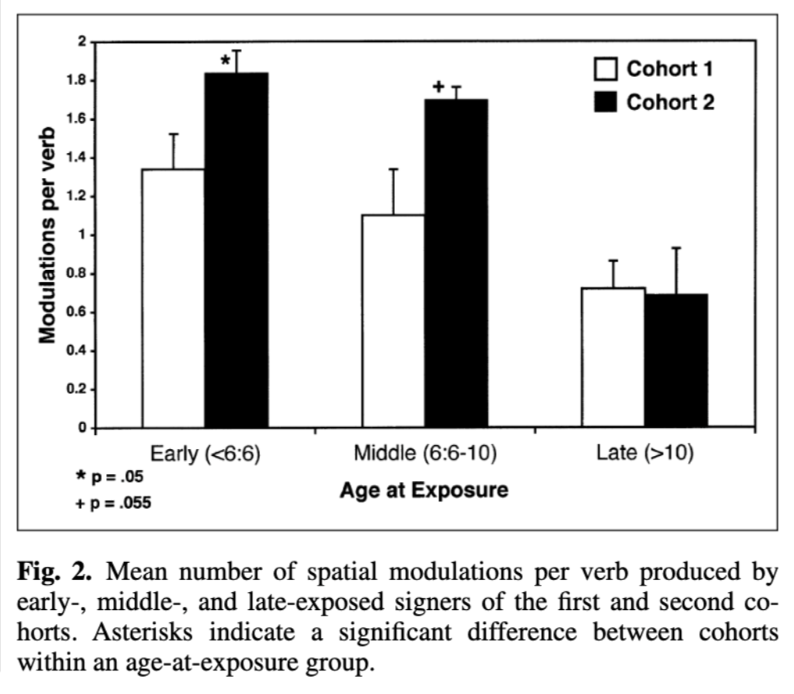

## Use of Spatial Modulations

* + 1. Look at Figure 2 above (also on page 326 of the article). Compare the number of spatial modulations per verb based on age of exposure (age group). Are there any differences between the Early, Middle, and Late groups?

Yes, the younger the participant, the higher number of spatial modulations per verb. The late age of exposure group has significantly less modulations per verb then the other two, younger age of exposure groups.

* + 1. Still using Figure 2, now compare differences in the number of modulations per verb based on generational cohort. Are there any clear differences between Cohort 1 and Cohort 2? Do these differences vary by age group?

Cohort 2 has dramatically larger use of modulations per verb. There is a slight variance in the trend in the Late age group but cohort 1 is essentially the same as Cohort 2.

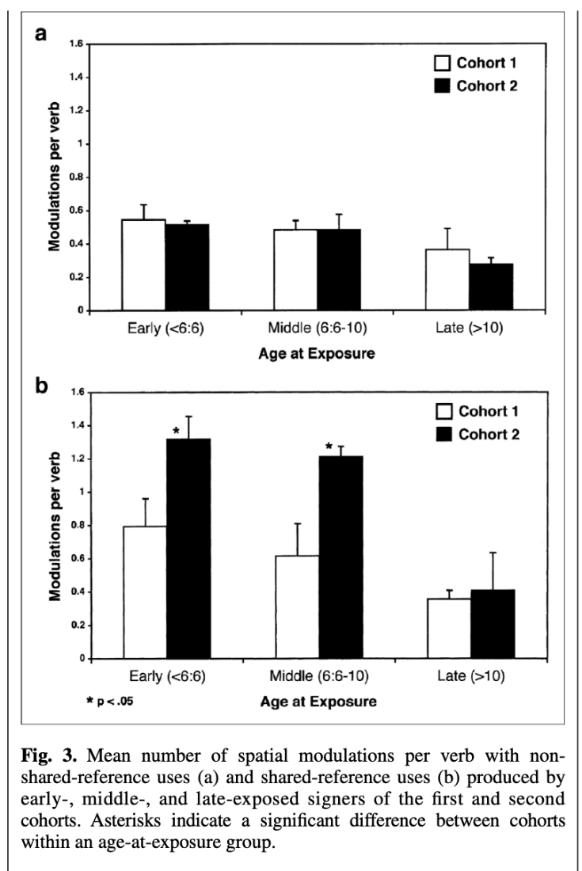

## Frequency of Shared-reference

* + 1. Look at Figure 3a (top) above (also on page 326 of the article), which showsthe results for non-shared reference uses of spatial modulations. Are there any differences in usage between the age groups or the cohorts?

The younger age groups barely use more but the cohorts are pretty much identical to their age group. No significant difference however.

* + 1. Now look at Figure 3b (bottom), which showsthe results for shared reference uses of spatial modulations. Are there any differences in usage between the age groups or the cohorts? Who uses spatial modulation to mark shared-reference the most?

Yes the early and middle learners in cohort 2 produced many more spatial modulation with shared reference use.

The Cohort data in the Early age and Middle age groups show that there is dramatically less modulations per verb used in cohort 1 then in Cohort 2 while in the Late age group the difference in modulations per verb used in cohort 1 and 2 are negligible.

# Section 3: Research Questions

* 1. Is Nicaraguan Sign Language becoming more complex over time? How do we know?

Yes the language is increasing in complexity. We know because of the statistics regarding Modulations per verb and cohorts.

* 1. Which speakers of Nicaraguan Sign Language are using increasingly complex language?

Signers in cohort 2 who learned the language early in life before the age of 10 are using increasingly complex language.

* 1. Who is driving change in the language? How do we know?

The younger signers in Cohort 2 who were exposed the Nicaraguan Sign Language at an early age are driving change. We know because of the we know because of the statistics regarding Modulations per verb, cohorts, and age groups.

# Section 4: Language Myths and Universal Grammar

* 1. How does Nicaraguan Sign Language provide crucial evidence against these two myths?

Children primarily learn language from their environment.

The children were being taught Spanish and lip reading in school.

Sign languages are just spelling or gesturing with hands.

Children were using their entire three dimensional space and facial expressions. They are also encoding grammatical concepts like shared reference.

Let’s think critically about what we can learn more generally about human language from this case study on Nicaraguan Sign Language.

* 1. What is the idea or claim of “Universal Grammar” (UG)?

All languages share some key concepts such as nouns, verbs, the ability to form a question, etc… UG is a proposed blueprint for language which is shared by all human beings and shapes all human languages. UG is often used to explain core properties shared across all languages as well as the range of ways in which languages differ from eachother.

* 1. Why is the birth and evolution of Nicaraguan Sign Language so interesting to the conversation about Universal Grammar? How might this case study support or oppose the claims of UG?

Even though the language is not spoken, it still has all the properties of spoken languages.